# Topic: Recommendation Engine

**Instructions:**

Please share your answers filled in-line in the word document. Submit code separately wherever applicable.

Please ensure you update all the details:

**Name: _____________ Batch ID:** ___________

**Topic: Recommender Engine**

**Guidelines:**

**1. An assignment submission is considered complete only when the correct and executable code(s) is submitted along with the documentation explaining the method and results. Failing to submit either of those will be considered an invalid submission and will not be considered a correct submission.**

**2. Ensure that you submit your assignments correctly and in full. Resubmission is not allowed.**

**3. Post the submission you can evaluate your work by referring to the keys provided. (will be available only post the submission).**

**Hints:**

1. **Business Problem**
   1. **What is the business objective?**
   2. **Are there any constraints?**
2. **Work on each feature of the dataset to create a data dictionary as displayed in the image below:**

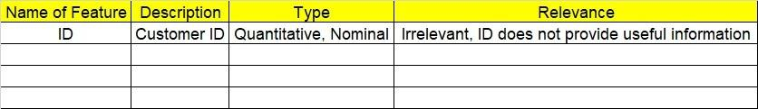

1. **Data Pre-processing**

**2.1 Data Cleaning and Data Mining.**

1. **Exploratory Data Analysis (EDA):**
   1. **Summary.**
   2. **Univariate analysis.**
   3. **Bivariate analysis.**
2. **Model Building**
   1. **Build the Recommender Engine model on the given data sets.**
3. **Write about the benefits/impact of the solution - in what way does the business (client) benefit from the solution provided?**

**Problem Statement: -**

Q1) Build a recommender system with the given data using UBCF.

This dataset is related to the video gaming industry and a survey was conducted to build a

recommendation engine so that the store can improve the sales of its gaming DVDs. A snapshotof the dataset is given below. Build a Recommendation Engine and suggest top-selling DVDs to the store customers.

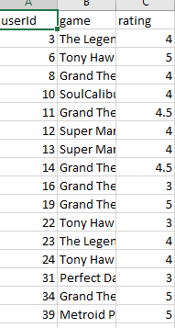

**Questions to Trigger Your thoughts:**

Q1. What are Recommendation Systems?

Q2. How are *Knowledge-based Recommender Systems* different from *Collaborative and Content-based Recommender Systems*?

Q3. What is the difference between Collaborative and Content-based Recommender Systems?

Q4. How does the surprise library work in the recommendation engine?

Q5. What are the three main types of recommendation engines?

Q6. What is the logic behind the recommendation engine?

Q7. What are the benefits of recommendation engines?

Q8. What is NLP usage in recommendation engines?

Q9. What is a *Model-Based Collaborative* approach?

Q10. Which are used for filtering in a Recommendation Engine?

Q11. For an eCommerce website which one is explicit data?

Q12. How would you create a Recommender System for Text Inputs?

Q13. What are the different methods that you can collect User Data for the Recommendation Process?

Q14. What are the different types of Memory-Based Collaborative approaches?